OVERALL PROGRAMME EVALUATION REPORT
SBVP ALUMNI MASTERCLASS - GROW Module II Online Kenya (16th March 2026 - 20th March 2026)
No. of Respondents: 12
No. of Participants: 130
Response Rate: 9%
--------------------------------------------------

Faculty Reports

Dr. Geoffrey Ikavulu Injeni - Long-term sustainability planning
Evaluation Parameter | (%) Individual Score | (%) Programme Average
Punctuality (Commencement and Completion of Sessions) | 98 | 98
How well do you understand the core concepts presented? | 88 | 93
Rate your confidence in applying the new skills learnt | 82 | 88
Degree of Faculty preparedness for the sessions | 96 | 98
Content and methodology of the program | 94 | 96
Quality of class and group discussions | 86 | 93
The information presented in the course is relevant to my work (ministry) | 96 | 98
Average scores | 91 | 95

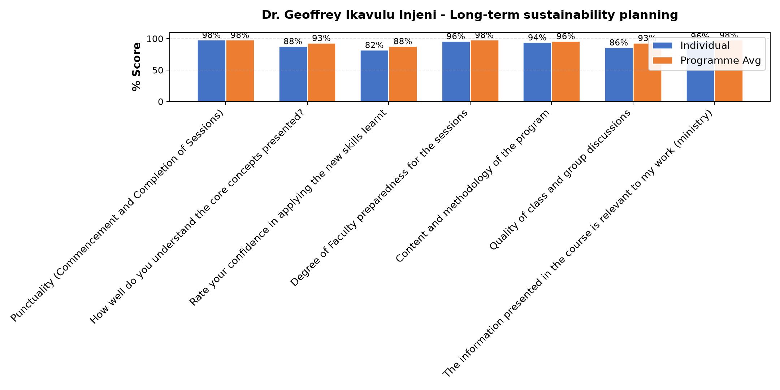

Comments & Feedback
- • Challenges in getting the finances to upgrade the project
- • Organisational changes that are affecting the project.
- • Resources and not directly involved in project
- • Lack of consideration of the 5 ps
- • If am not able to use well the information I got on how to run our enterprise
- • Government policies and financial constraints
- • The congregation structure about finances.
- • Lack of resources

Dr. Nancy Nyambura Njiraini - Reflections and Way Forward
Evaluation Parameter | (%) Individual Score | (%) Programme Average
Punctuality (Commencement and Completion of Sessions) | 98 | 98
How well do you understand the core concepts presented? | 98 | 93
Rate your confidence in applying the new skills learnt | 93 | 88
Degree of Faculty preparedness for the sessions | 100 | 98
Content and methodology of the program | 98 | 96
Quality of class and group discussions | 98 | 93
The information presented in the course is relevant to my work (ministry) | 100 | 98
Average scores | 98 | 95

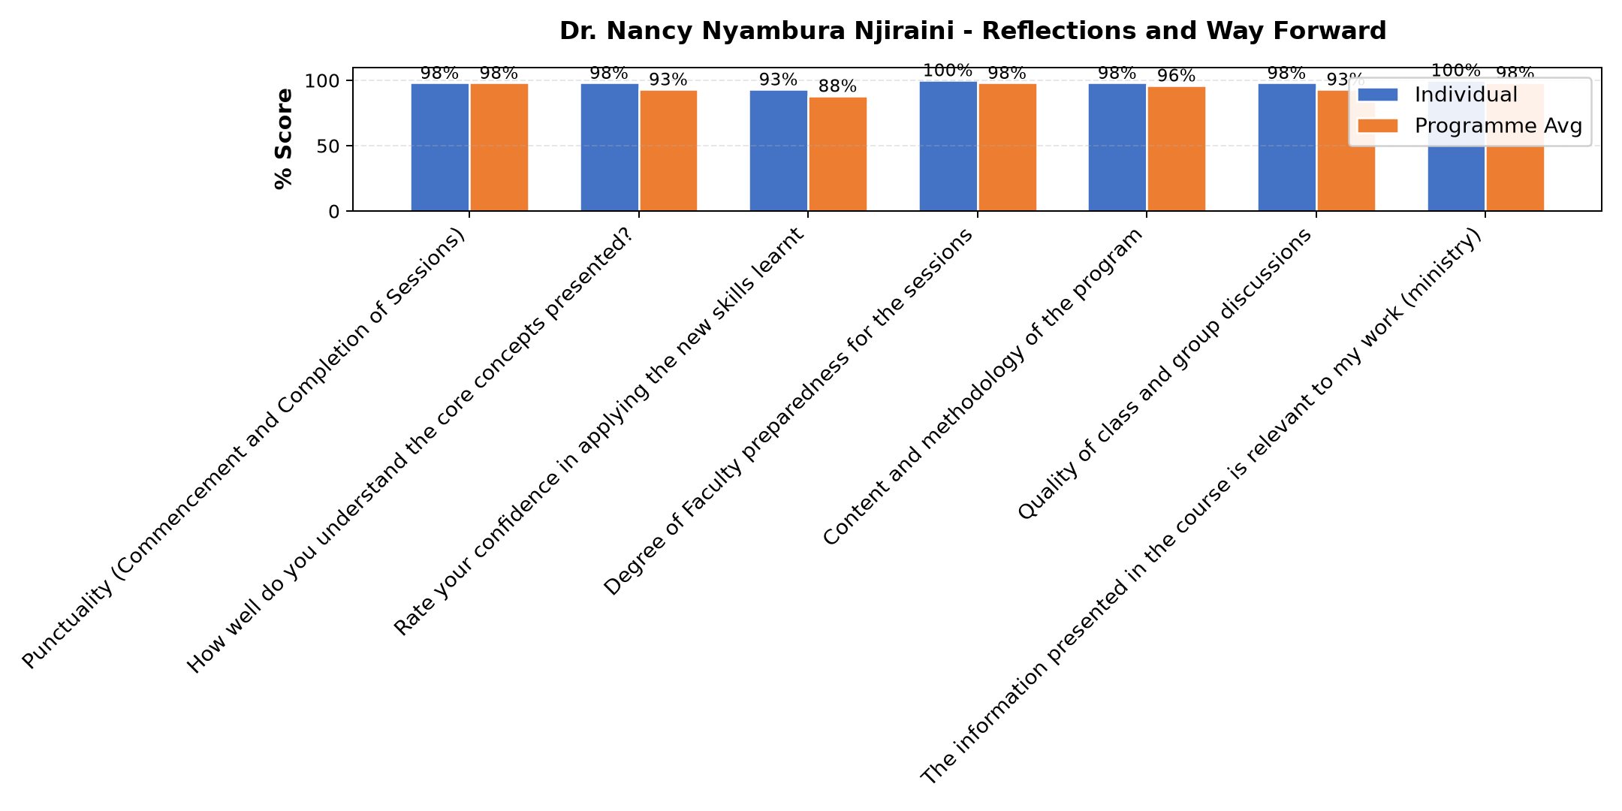

Comments & Feedback
- • Financial constraints
- • If am not able to recognize the challenges that the enterprise is facing so as to address them and go on.
- • Thank you the input is and will be of a great help
- • Lack of knowledge, skills and commitment.
- • Leadership and governance problem
- • If no total support from the my leadership.
- • Ridgity of leaders to accept the suggestion s
- • Ignorance. All was well elaborated
- • Any unexpected changes in the project administration, otherwise we are committed to support implementation through the application of all learnt knowledge.

Dr. William Karani Murithi - Review (identify gaps/challenges) your business plan from module 1 || Decide key issues for long-term sustainability || Identify areas where support is needed
Evaluation Parameter | (%) Individual Score | (%) Programme Average
Punctuality (Commencement and Completion of Sessions) | 98 | 98
How well do you understand the core concepts presented? | 93 | 93
Rate your confidence in applying the new skills learnt | 85 | 88
Degree of Faculty preparedness for the sessions | 98 | 98
Content and methodology of the program | 92 | 96
Quality of class and group discussions | 95 | 93
The information presented in the course is relevant to my work (ministry) | 96 | 98
Average scores | 94 | 95

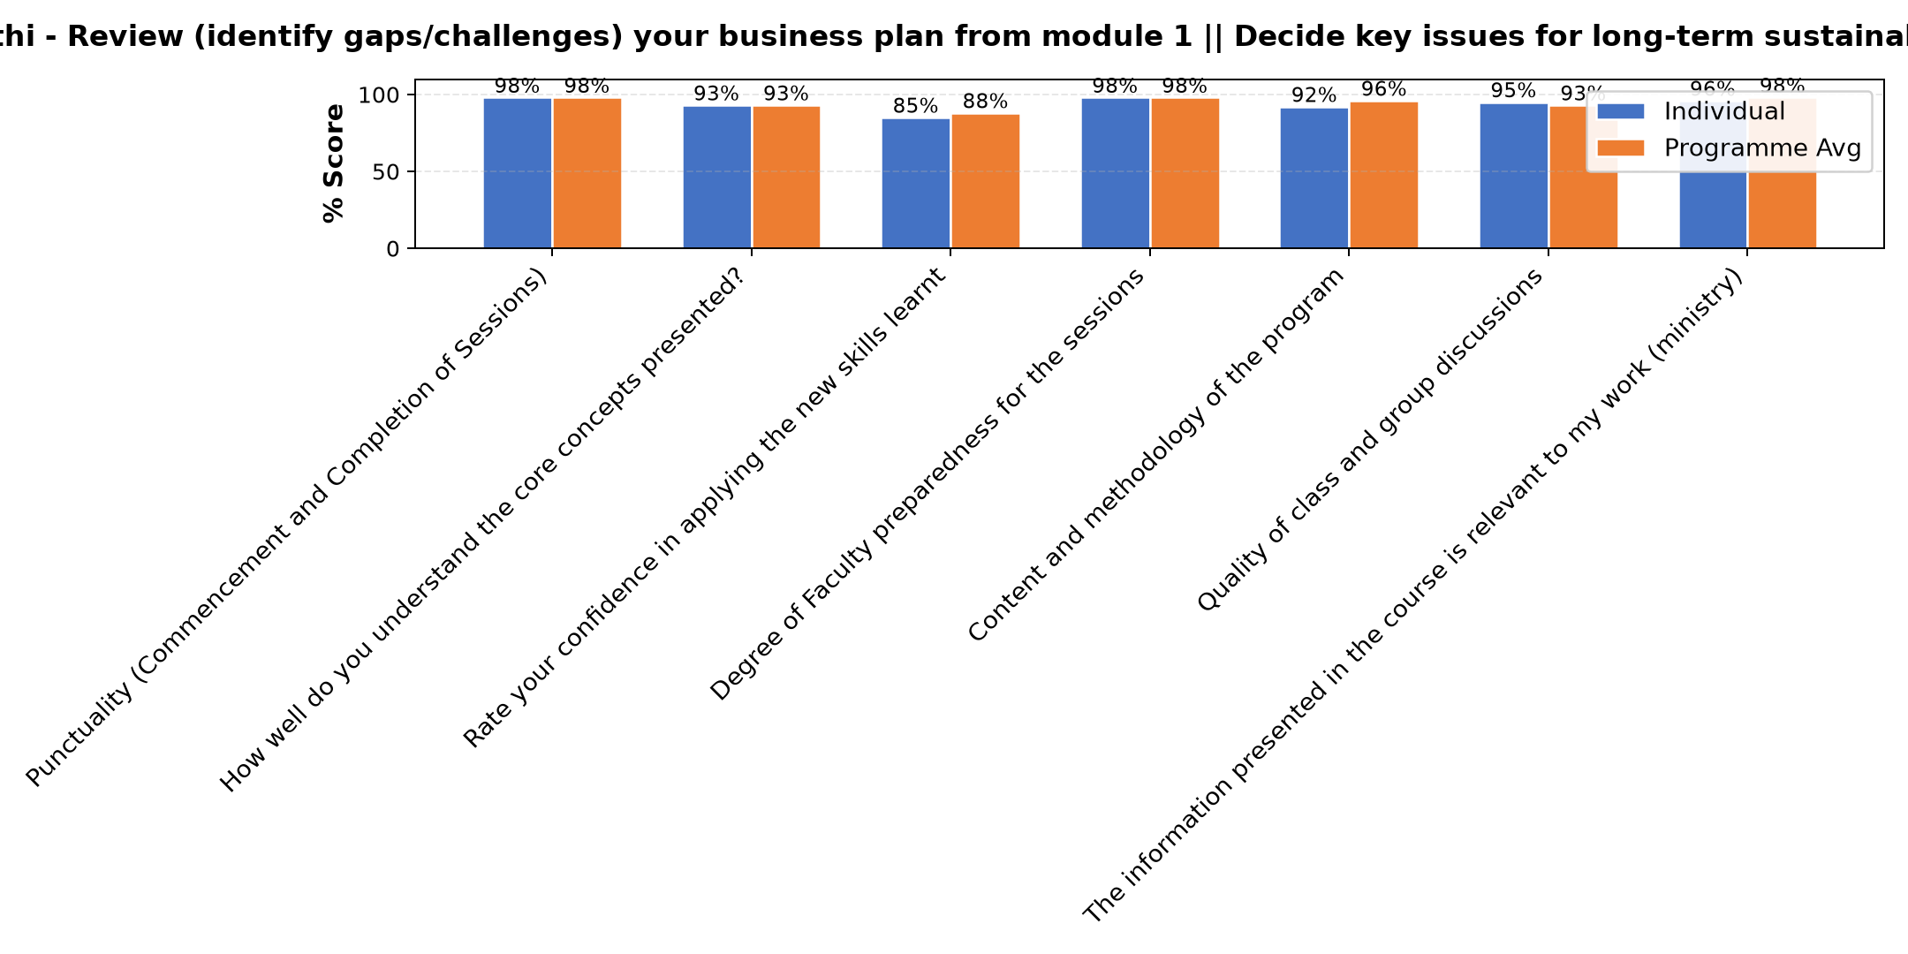

Comments & Feedback
- • Financial thanks to Hilton foundation and Strathmore University
- • Financial constraints
- • Any unplanned changes in the project administration. Otherwise we are committed to applying for he knowledge gained in implementation of the project.
- • Inadequate finances
- • Slowness in engaging the partners and stakeholders in the enterprise
- • The input was very rich
- • Lack of review of our business plan and genuine evaluation of the social enterprise.
- • Lack of enough finance especially during long holidays when we have students out of our hostel facility

Dr. Isaac Muiruri Gachanja - Review current funding of social enterprise || Identify Funding Gaps || Preparing funding plan
Evaluation Parameter | (%) Individual Score | (%) Programme Average
Punctuality (Commencement and Completion of Sessions) | 97 | 98
How well do you understand the core concepts presented? | 93 | 93
Rate your confidence in applying the new skills learnt | 92 | 88
Degree of Faculty preparedness for the sessions | 98 | 98
Content and methodology of the program | 98 | 96
Quality of class and group discussions | 92 | 93
The information presented in the course is relevant to my work (ministry) | 98 | 98
Average scores | 95 | 95

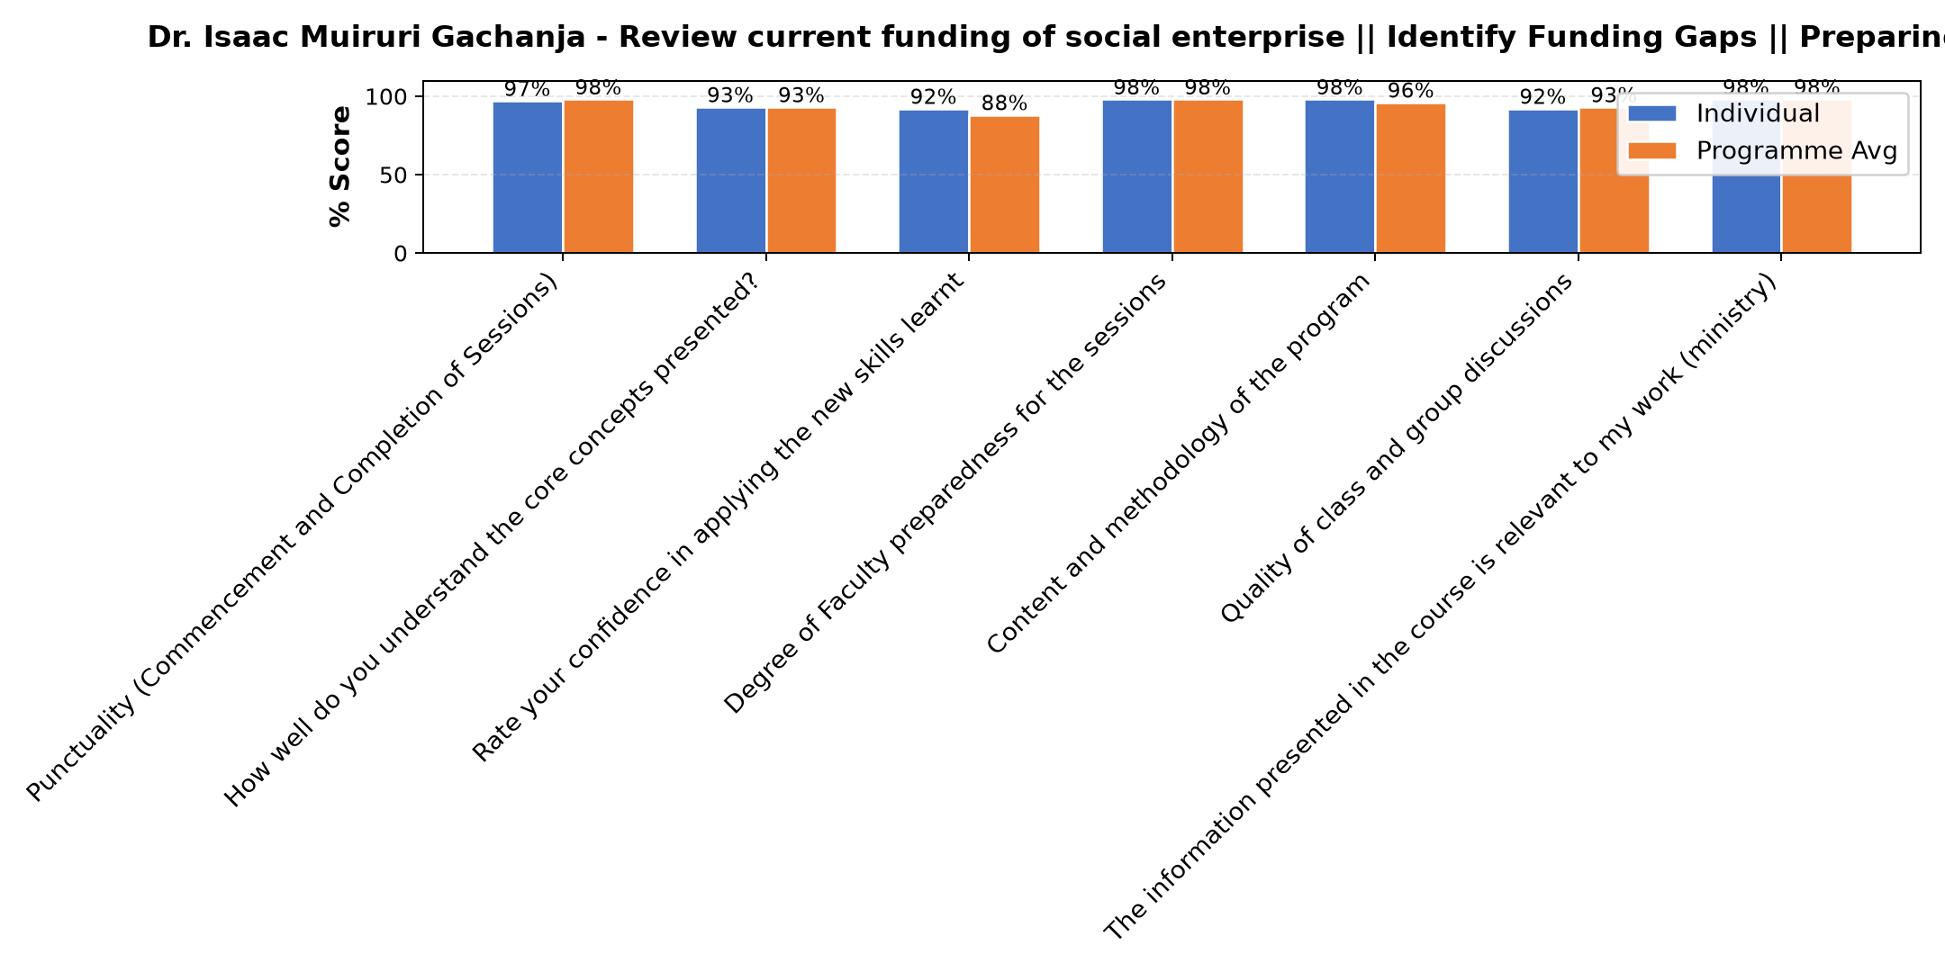

Comments & Feedback
- • Financial problems
- • Organization transition challenges
- • lack of efficient networking
- • Financial instability
- • Fear of bank loans incase i default
- • Lack of proper skills to write proposal for funding
- • Nothing
- • If I allow our enterprise remain in the valley of death.
- • All went on well

Department Reports

Are there any other comments and/or suggestions that you may want to add?

Comments & Feedback
- • I wish to thank Strathmore fraternity for the effort you have put in to help us implement Business plans appropriately
- • Thank you
- • God bless your good work 🙏
- • May be we have this program during holiday.
- • If possible to consider when schools are in holidays or to conduct the sessions in the evenings 8:00 pm to 10:00 pm to avoid being divided.
- • Deep appreciation to all SBS faculty members who dedicated their time and energy in preparation and delivering the sessions. Thanks to Strathmore University for on boarding the SBVP and continuously working towards the best for each sister participant and the common good of all the congregations. We look forward to the continued support in implementing our social enterprises with renewed vision and long term sustainability.

Further Comments

Comments & Feedback
- • Thanks for the insights given i am happy to learn more on improving our social enterprise and the accompanyment given,
- • The materials were well researched. I request if the slides can be shared for reference.
- • Well done job
- • Thanks for organizing this program it's very helpful
- • The probing questions very helpful in knowing the right way to go
- • Thanks. More time was needed for more discussion.
- • The lecturers are thorough letting us get findings by ourselves through discussion and sharing.thank you
- • Thanks to Dr for the enlightenment and encouraging us that even if Donner fail keeping trying
- • Am grateful for the insights and getting each day. Be blessed
- • The session was well presented and insightful. Add my knowledge on funding for social enterprises and challenged me to keep exploring avenues for generating sustainable revenues for our society enterprises
- • it is wonderful to be part of this program
- • So wonderful to have such a great person helping us with more ideas on how to grow our social enterprises. It's true we can't grow when we are in the comfort zone, commitment and determination crowns it all. God bless you abundantly
- • It was an interactive presentation and also an eye opener,thanks
- • Need more insights
- • Thanks of organizing for this training it's very empowering
- • The sessions were well reflected and presented. Provided clarity on sustainability planning indicating the importance of regular review of our business plan as a living document to provide direction on the overall performance of our social enterprise and expected social impact.
- • Thank you for the contribution towards uplifting our social enterprises through well selected topics relevant to the enterprises.
- • I am blessed to be in this program because it opens doors for progress which were unknown to me. Thank you very much Strathmore fraternity
- • Thanks alot
- • Thank Dada Lucy for being part of support team for our enterprise. God bless you all.
- • Recommendable job
- • Thank you
- • So lovely it was indeed. I've learnt that challenges are a stepping stones to succeed and achieving the goals set.
- • Please involve our Congregation leaders fully so that we can have good results.
- • Thanks for all the input
- • The whole session was lively & transformative.
- • We appreciate the efforts of SBS to help us as congregations to develop our social enterprises into long term sustainable entities.
- • Recommendable job

Overall Evaluation
Evaluation Parameter | (%) Score
Overall program evaluation | 96
Average score | 96

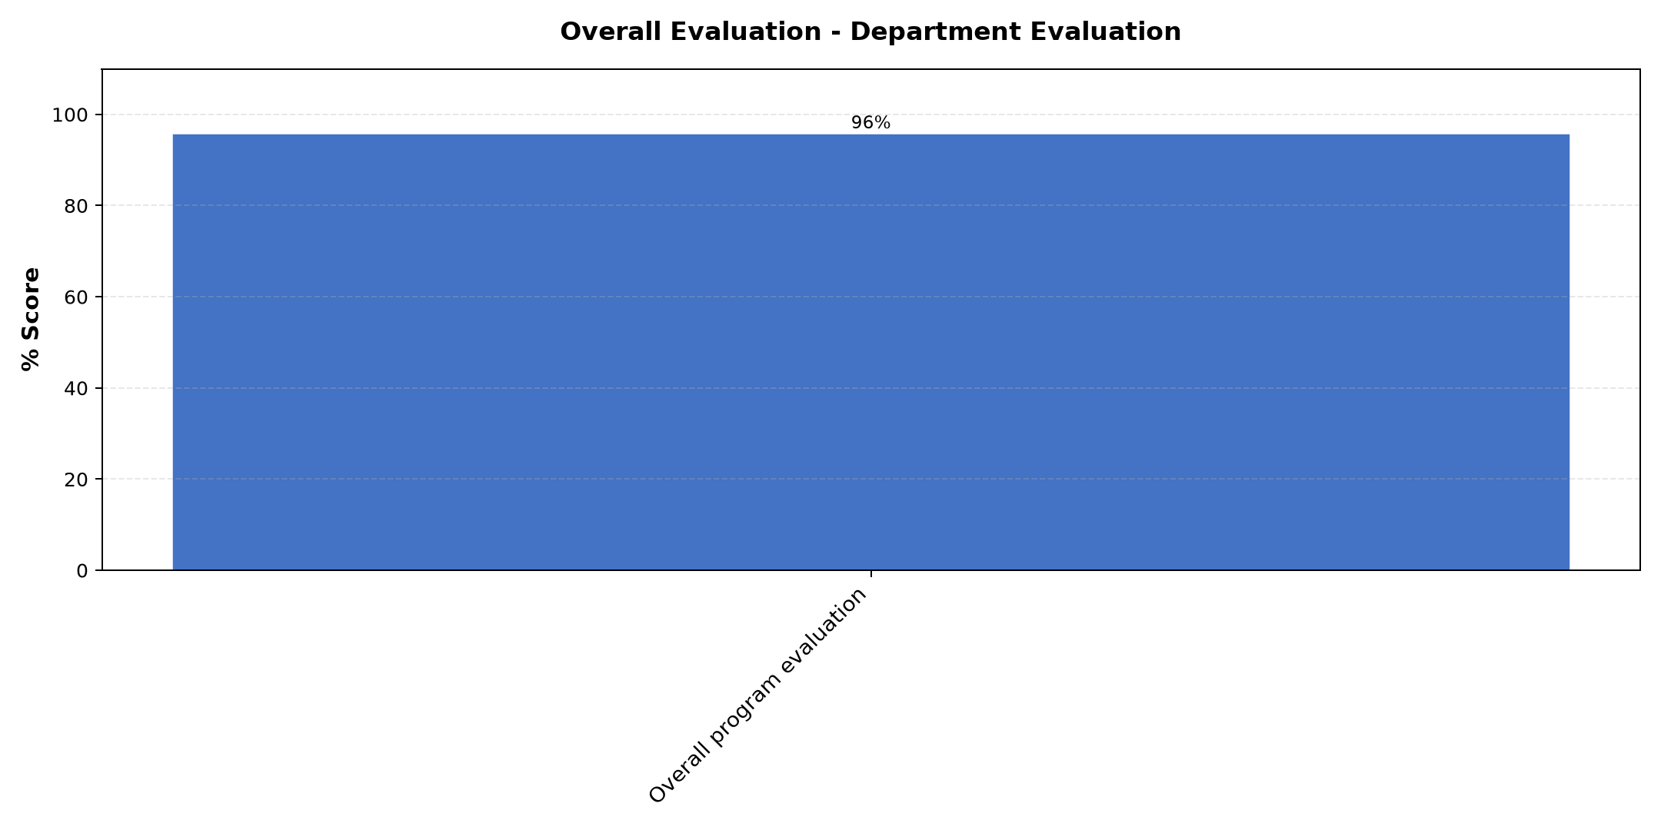

Comments & Feedback
No comments recorded.

What attracted you to the programme??

Comments & Feedback
- • Success stories from the enterprises being implemented
- • The follow up of our projects to know how where we are after the training.
- • It's for the good of our enterprise
- • Preparedness of the faculties. Was so wonderful 👍
- • The social impact that comes with this project.
- • Charism of our congregation which is Uplifting the life of the humanity through maternal donation by serving today's realities ie education, health, social work, evangelization. The experience I have had of women and children suffering due to poverty have motivated me to take up the program and also the struggles in our congregation to sustain the family.
- • To acquire the skills & knowledge to help my congregation to be self sustainable.
- • To learn more about social enterprise development to gain practical knowledge and skills to support our ongoing social enterprises in the congregation. My hope is to see the our health center become sustainable
- • Wishing to improve our social enterprise

What topic would you recommend being expanded/improved in this programme’s units?

Comments & Feedback
- • Business plan evaluation
- • Impact goals and measure.
- • MAPPING FUNDING SOURCES:Even though it was elaborated well repeating it will be of great help
- • Ways of managing and sourcing funds
- • More time and follow up would help.
- • Preparing funding plan
- • Leadership & Governance
- • Long tern sustainability planning. This will help us to make clear projections and measure impact continuously.
- • To identify the gap

Which areas in this programme did you find most important to your social enterprise?

Comments & Feedback
- • Social impacts ,Business plan evaluation.
- • Evaluation of our business plan
- • On impact measurements and reviewing of business plan
- • Importance of Business plan review and follow up for the growth of our enterprise
- • Each topic was very key and important to this project.
- • Evaluating the growth of our Se, and planning of its sustainability
- • All areas planned were impactful & needed for my social enterprise to grow, be effective & productive to attain desired sustainability.
- • Review of business plan and loner term sustainability planning and measurement of social impact.

Which teaching methods applied in the course did you enjoy/learn from the most?

Comments & Feedback
- • Question and answer
- • Each was involved
- • Group discussion and presentation guidance
- • Team work and discuss
- • Presentations,discussion groups, questions and answers
- • Reflection, discussion & presentation.
- • Small group discussion and Presentations of congregation own experiences of day today operations

Program Manager (Sr. Felister Kizia)
Evaluation Parameter | (%) Score
Punctuality in sending materials and programme information | 100
Communication skills(verbal and written) | 100
Response to programme enquiries via email, whatsapp and calls | 98
Accessibility and willingness to support when needed | 98
Quality of service / professionalism | 100
Average score | 99

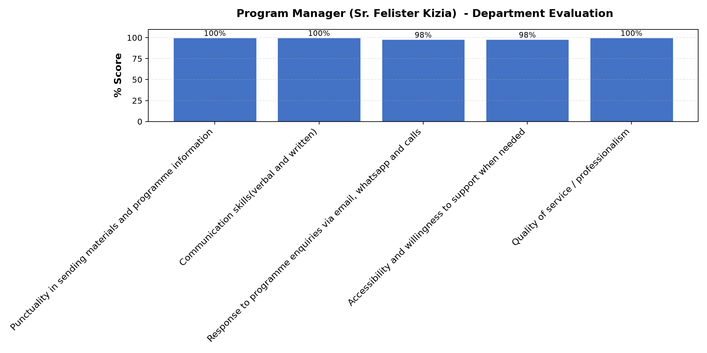

Comments & Feedback
- • God bless you all.SBVP and the Strathmore team.
- • Thanks Sr. For your efforts in making sure each participated to an extent of even using WhatsApp call for those who couldn't manage to use zoom
- • It's so nice being attached to Strathmore University. They have good and qualified faculties who have made us realize the possibilities in growth of every projects we carry out. Personally I feel so moved and encouraged to put more effort and to hold the enterprise at Heart. God bless you
- • Thanks for the availability.
- • She reaches out to the person to find out incase of challenges.
- • Looking forward for more interactions and inputs from the program as we continue to implement.
- • Appreciate the program coordinators for their patience and understanding in coordinating the program, kind follow up of sisters individually and as a congregation and calling everyone to attention throughout the sessions throughout the training and implementation of our social enterprises.
- • Workshop try to be planned when school are in mind term to avoid

